CONNECTING TO A DATABASE IN VB.net

Go to mysql query browser

Let username be default

Put password

Next

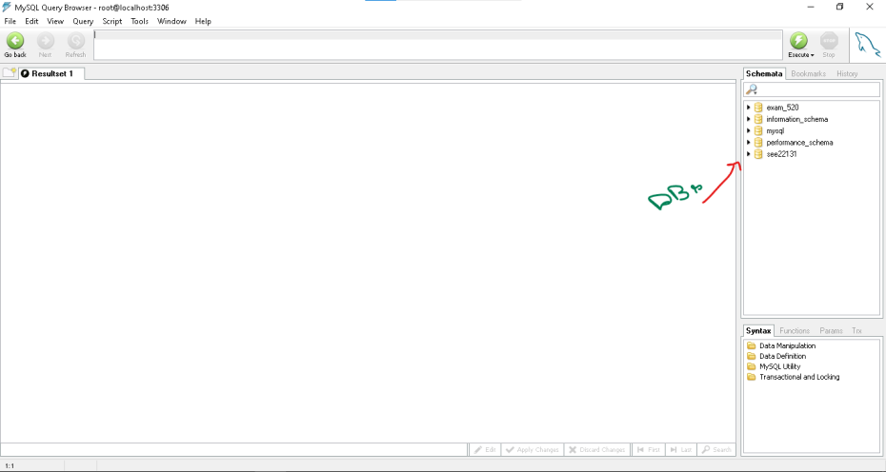

Right click in empty space and click on create new schema

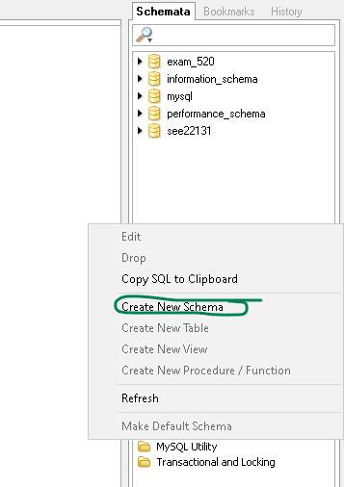

Double click on 22135_saniya

Right click on it and “create new table”

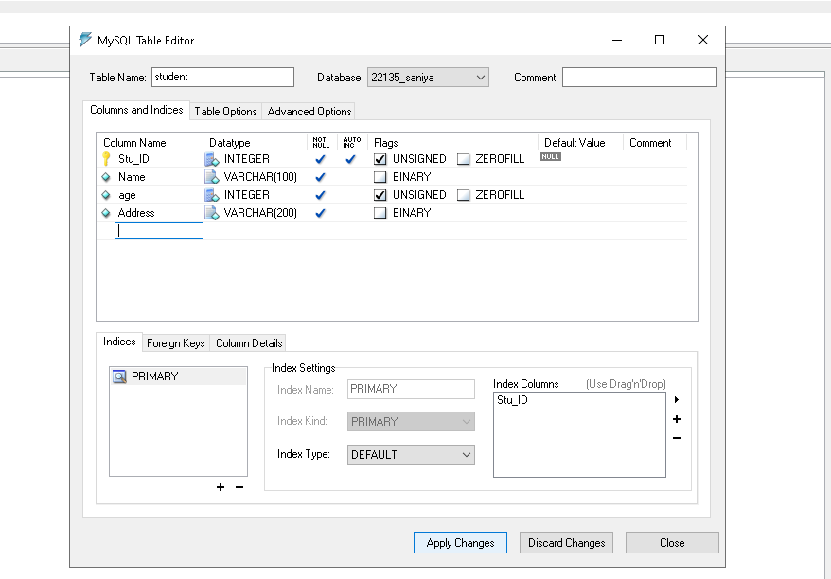

Type in that top place for query

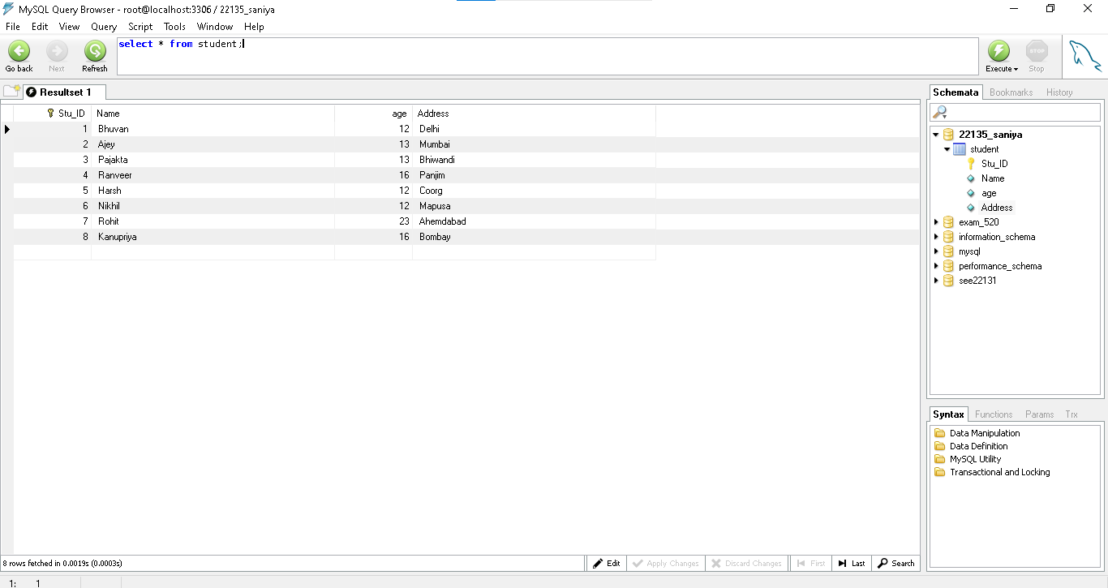

insert into student

values(02,"Ajey",13,"Mumbai");

insert into student

values(01,"Bhuvan",15,"Mumbai");

insert into student

values(03,"Pajakta",13,"Bhiwandi");

insert into student

values(04,"Ranveer",16,"Panjim ");

insert into student

values(05,"Harsh",12,"Coorg");

insert into student

values(06,"Nikhil",12,"Mapusa");

insert into student

values(07,"Rohit",23,"Ahemdabad");

insert into student

values(08,"Kanupriya",16,"Bombay");

go to vs

create a new form

toolbox : datagridview

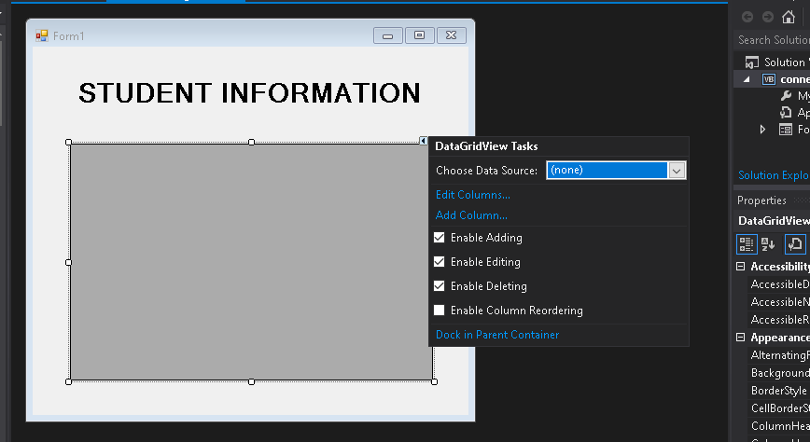

Open (none dropdown)

Add project data source

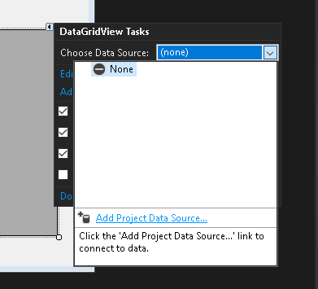

Click on database

Dataset

New connection

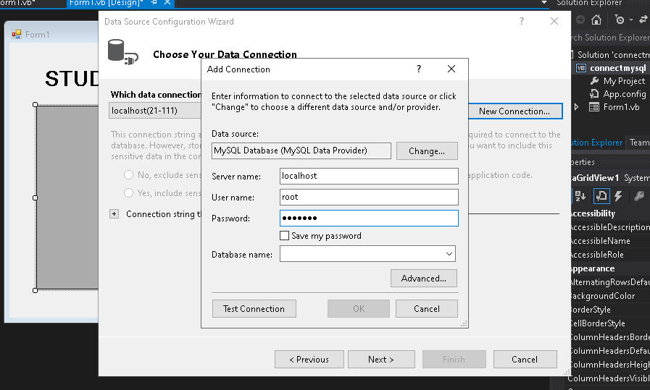

Database name : select the db

TEST CONNECTION

OK

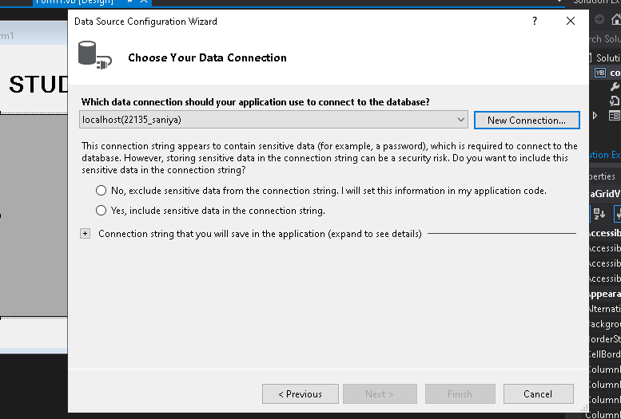

YES INCLUDE

NEXT NEXT

TABLE

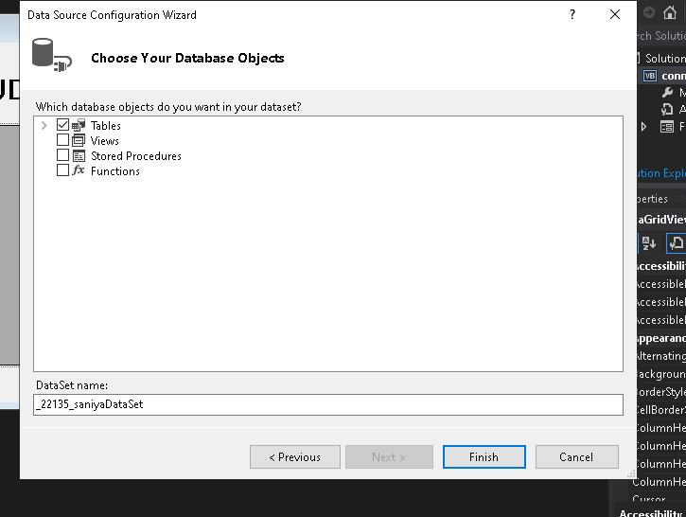

FINISH

RUN APP

Add refersh button and copy code

